DESKTOP TYPE OF LABEL PRINTER
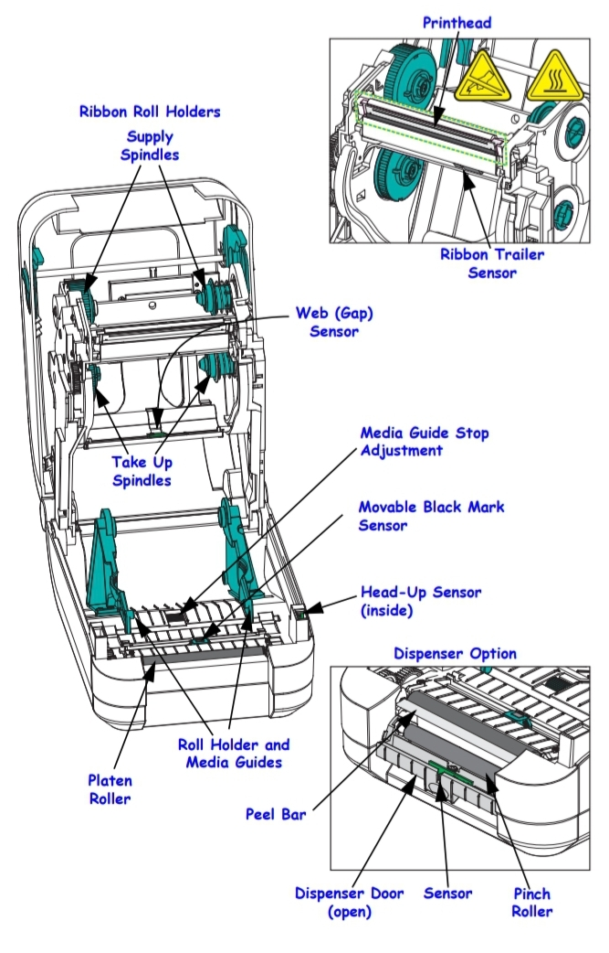
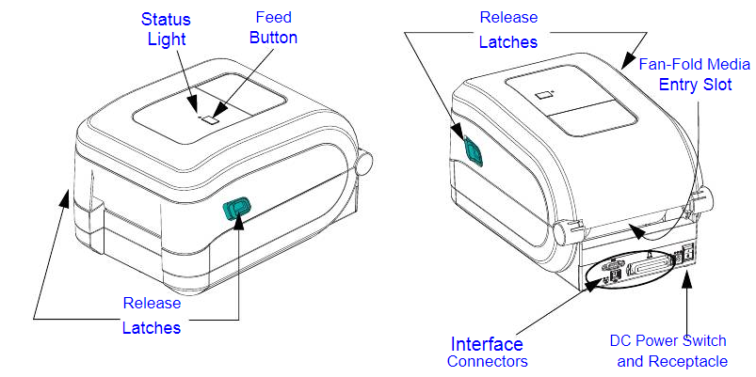

INDUSTRIAL TYPE OF BARCODE PRINTER
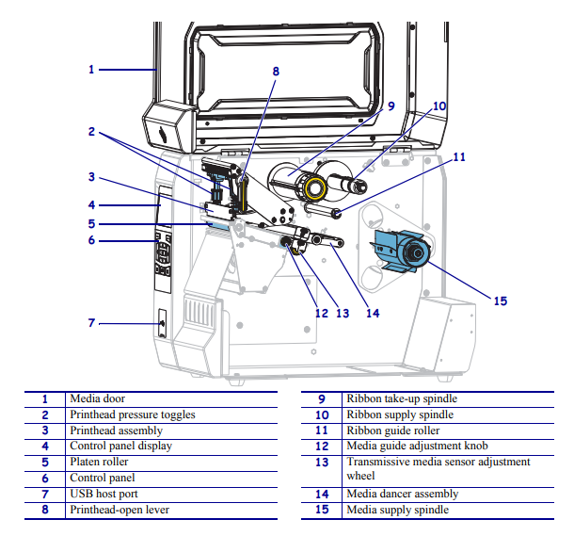

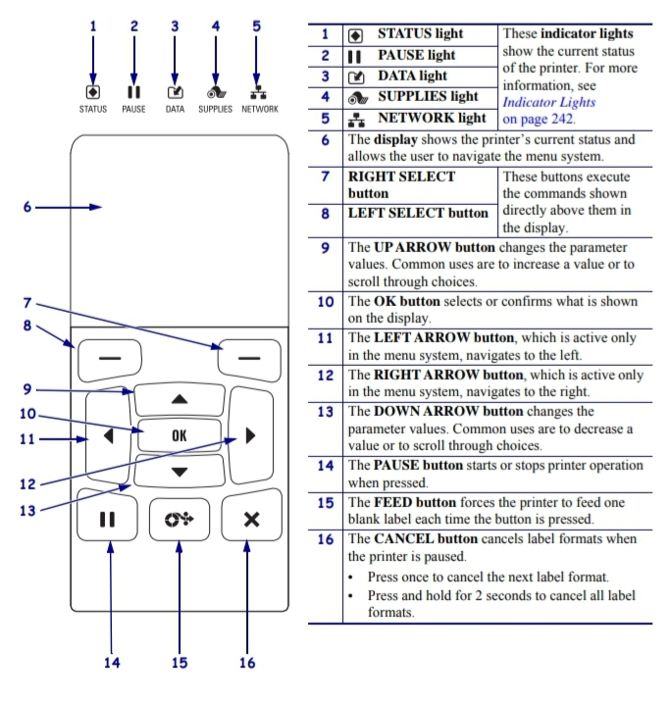

Printer Check-List

Customer :
Location : Division :
___________________________________________________________________

Brand/ Model :
Part# Serial#

Task:
☐ Media Door ☐ Media door release latches
☐ Printehead ☐ Overall print quality
☐ Control panel display ☐ Panel button
☐ Platen roller ☐ Remove excess label material
☐ Clean interior printer ☐ Clean exterior printer
☐ Media sensor ☐ Rewinder
☐ Cutter ☐ Perform self test
☐ Software/ Driver ☐ Power button
☐ Printer status light (On/ Off) ☐ Ribbon & media holder
☐ Port interface/ connector (USB/ Serial/ LAN/ Parallel)
☐ Others _________________

Remarks

Check Date Engineer

