

Copyright©2020 Jovision Technology Co., Ltd.

All rights reserved.

http://en.jovision.com/

**JVS-FRT-P8**

**User Manual**

# Statement

Thank you for choosing Jovision, this user manual is intended for users of Face Recognition System. It includes instructions on how to use the product. Before using the device, read the user manual carefully. Keep this manual for further clarifications. The descriptions, images and technical parameters may vary with the actual devices. The software embodied in the product is governed by the user license agreement covering that product.

**Copyright**

This Manual is subject to domestic and international copyright protection.

Jovision Technology Co., Ltd. (“Jovision”) reserves all rights to this manual. This manual cannot be reproduced, changed, translated, or distributed, partially or wholly, by any means, without the prior written permission of Jovision.

**Privacy Notice**

Surveillance &Privacy laws vary by jurisdiction. Check all relevant laws in your jurisdiction before using this product for surveillance purposes to ensure that your use of this product conforms. Please refer to the product specification for camera parameters and functions.

**Disclaimer**

This manual is for reference only. It may contain several technical incorrect places or printing errors, and the content is subject to change without notice. All information in this booklet has been thoroughly reviewed. Jovision Technology Co., Ltd. is not liable for damage caused by improper use of this device.

**Regulatory Information**

**FCC Caution.**

This device complies with part 15 of the FCC Rules. Operation is subject to the following two conditions: (1) This device may not cause harmful interference, and (2) this device must accept any interference received, including interference that may cause undesired operation.

Any Changes or modifications not expressly approved by the party responsible for compliance could void the user's authority to operate the equipment.

**Note**: This equipment has been tested and found to comply with the limits for a Class B digital device, pursuant to part 15 of the FCC Rules. These limits are designed to provide reasonable protection against harmful interference in a residential installation. This equipment generates uses and can radiate radio frequency energy and, if not installed and used in accordance with the instructions, may cause harmful interference to radio communications. However, there is no guarantee that interference will not occur in a particular installation. If this equipment does cause harmful interference to radio or television reception, which can be determined by turning the equipment off and on, the user is encouraged to try to correct the interference by one or more of the following measures:

-Reorient or relocate the receiving antenna.

-Increase the separation between the equipment and receiver.

-Connect the equipment into an outlet on a circuit different from that to which the receiver is connected.

Consult the dealer or an experienced technician for help.

**RF warning**:

This equipment complies with FCC radiation exposure limits set forth for an uncontrolled environment. This equipment should be installed and operated with minimum distance 20cm between the radiator & your body.

**EU Conformity Statement**

This product and if applicable, the supplied accessories too are marked with "CE" and comply therefore with the applicable harmonized European standards listed under the Low Voltage Directive 2014/35/EU, the EMC Directive 2014/30/EU, the RED directive 2014/53/EU, the RoHS Directive 2011/65/EU.

This product can be used across EU member states.

The simplified EU declaration of conformity referred to in Article 10(9) shall be provided as follows:

Hereby, (Jovision Technology Co., Ltd.) declares that the radio equipment type (HD Network Camera) is in compliance with Directive 2014/53/EU.

2012/ 19/ EU (WEEE directive): Products marked with this symbol cannot be disposed of as unsorted municipal waste in the European Union. For proper recycling, return this product to your local supplier upon the purchase of equivalent new equipment, or dispose of it at designated collection points. For more information see: [www.recyclethis.info](http://www.recyclethis.info)

2006/ 66/ EC (battery directive): This product contains a battery that cannot be disposed of as unsorted municipal waste in the European Union. See the product documentation for specific battery information. The battery is marked with this symbol, which may include lettering to indicate cadmium (Cd), lead (Pb), or mercury (Hg). For proper recycling, return the battery to your supplier or to a designated collection point. For more information see: [www.recyclethis.info](http://www.recyclethis.info)

**WARNING**: Installation and servicing should be performed only by qualified and experienced technicians to conform to all local codes and to maintain your warranty.

**WARNING**: This device is configured for 12V DC operation only. Do not connect to a higher voltage. Use only with NRTL approved Class 2 or LPS power supplies. To prevent potential ground loop issues, a separate PSU should be used for each camera. A multiple-output PSU may be used if the multiple output PSU has isolated and protected (2A max) outputs.

**Open Source Software License**

This product contains software whose right holders license it under the terms of the GNU General Public License, version 2 (GPLv2), version 3 (GPLv3) and/or other open source software licenses. If you want to receive the complete corresponding source code, we will provide you and any third party with the source code of the software licensed under an open source software license if you send us a written request by mail or email to the following addresses:

Jovision OSS support team Email: opensource@jovision.com

Postal: Jovision Technology Co., Ltd.

Floor 12 Building No.3, Aosheng Square, NO.1166 Xinluo Street, Jinan, Shandong, China

Detailing the name of the product and the firmware version for which you want the source code and indicating how we can contact you.

Please note that we will ask you to pay us for the costs of a data carrier and the postal charges to send the data carrier to you. The amount can be varied according to your location and Geniatech oss support team will notify the exact cost when receiving the request. This offer is valid for three years from the moment we distributed the product and valid for as long as we offer spare parts or customer support for that product model.

**Important Safety Instructions**

* Read and keep these instructions.
* Ensure that your installation area can safely support 3 times the weight of the device.
* Do not install the device in extreme temperature conditions. Only use the device where temperatures are within the limits shown in the device specifications. Be especially careful to provide ventilation when operating under high temperatures.
* Do not install indoor rated devices where they will be exposed to rain or moisture.
* To prevent damage to the image, do not aim the device toward an extreme light source.
* Do not touch the device lens, dome or bezel (front glass plate).
* Do not drop the device or subject it to physical shock.
* Do not use strong or abrasive cleaners, clean only with a soft cloth and mild detergent or alcohol.
* Do not open the device or attempt to service it yourself. Refer all service issues to your dealer.

**Product Features**

This 3-in-1 Face Recognition and Temperature Measurement is a smart access control terminal that is independently designed and developed by Jovision Technology Co., Ltd. It combined with IR Human Recognition and High Precision Temperature Measurement. It used for Instant No-contact human body Temperature detection, Registration, Recording and Other functions, widely used in access gates, office areas, office buildings, hotels, schools, hospitals, airports, shopping malls, communities and other public places etc.

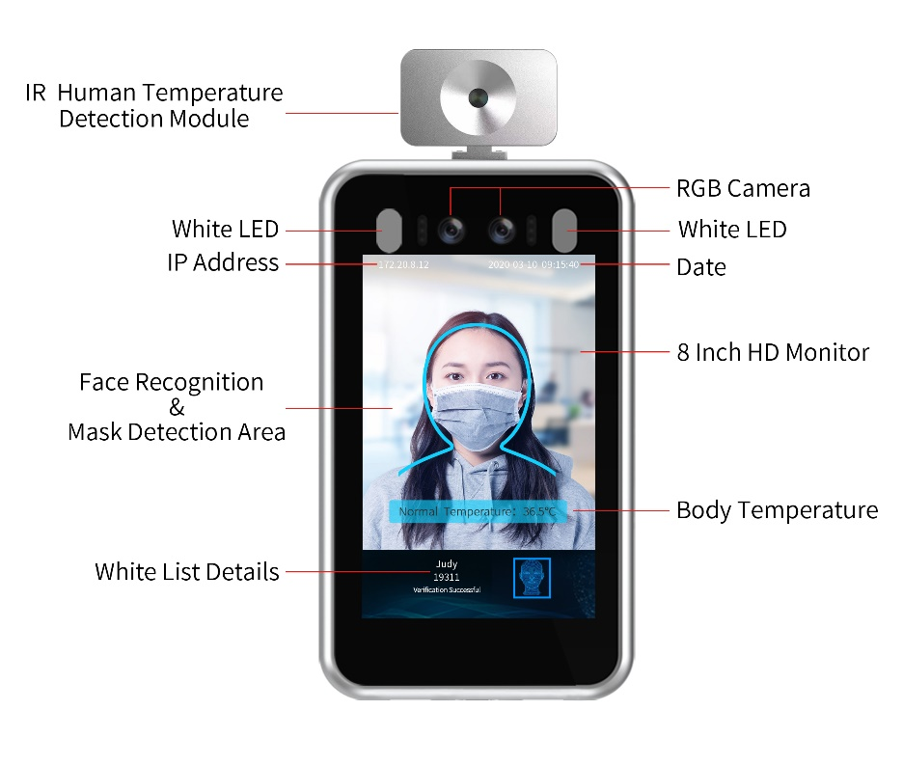

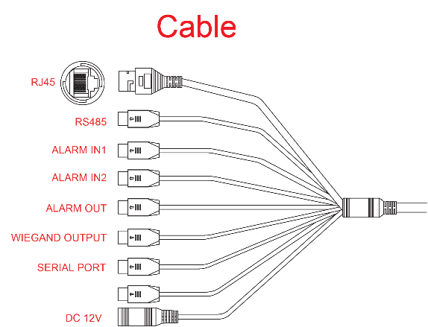**Overview**

**Installation**

Before you start:

1. Please make sure that the device is in good condition and all of the assembly parts are included.
2. Make sure that all related equipment is powered-off during the installation.
3. Check that the device specification agrees with the installation environment.
4. To avoid damage, ensure the power supply voltage matches your device requirements.
5. Please make sure the installation surface is strong enough to withstand three times the weight of the device and the mounting.
6. If the installation surface is concrete, you need to insert expansion screws before you install the device. If the installation surface is wood, you can use self-tapping screws to secure the device.
7. If the product does not function properly, please contact your dealer or the nearest service center. Do not disassemble the device for repair or maintenance by yourself.

Note: The pictures shown in this manual is for reference only, different models may vary its shape and structures. Please take actual product as standard.

**Installation**

Rack Mounting

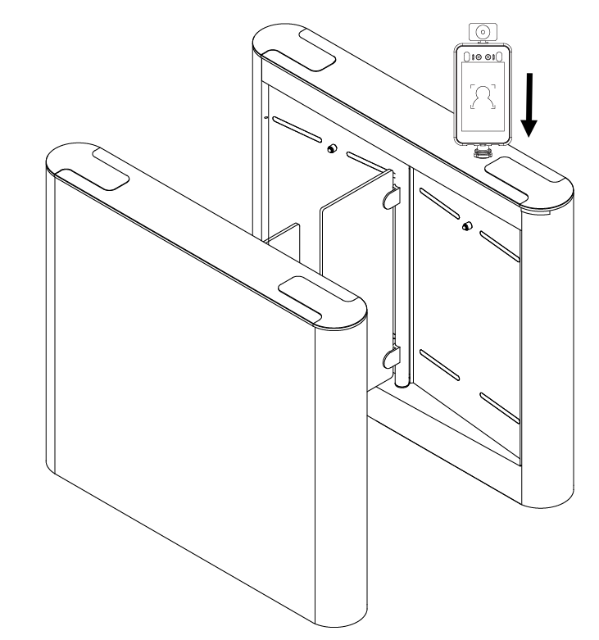

Turnstile Installation

Fix the face recognition device on the turnstile or a rack with the bracket provided with the rack mounting bracket.

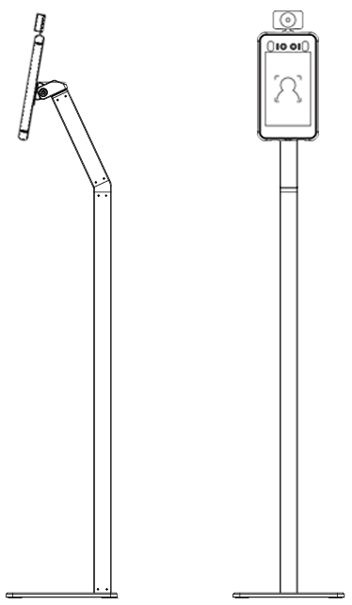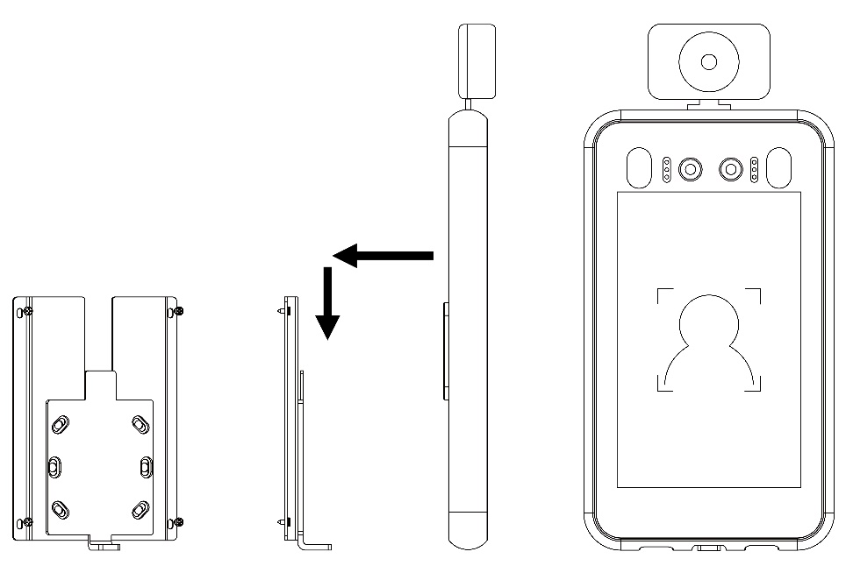Wall Mounting or Stand Mounting

**OR**

Stand Installation

Wall Mount Installation

Fix the wall bracket on the wall or stand. Place the face recognition device on the bracket and slide it down to fix properly.

**Temperature Measurement Function**

Turn on the Temperature measurement and detection function

Step 1: Got to **Intelligent Analysis -> Face Detection -> Basic**. Tick Temperature Detection to turn on the function. You can set the temperature unit and Alarm temperature in this setting.

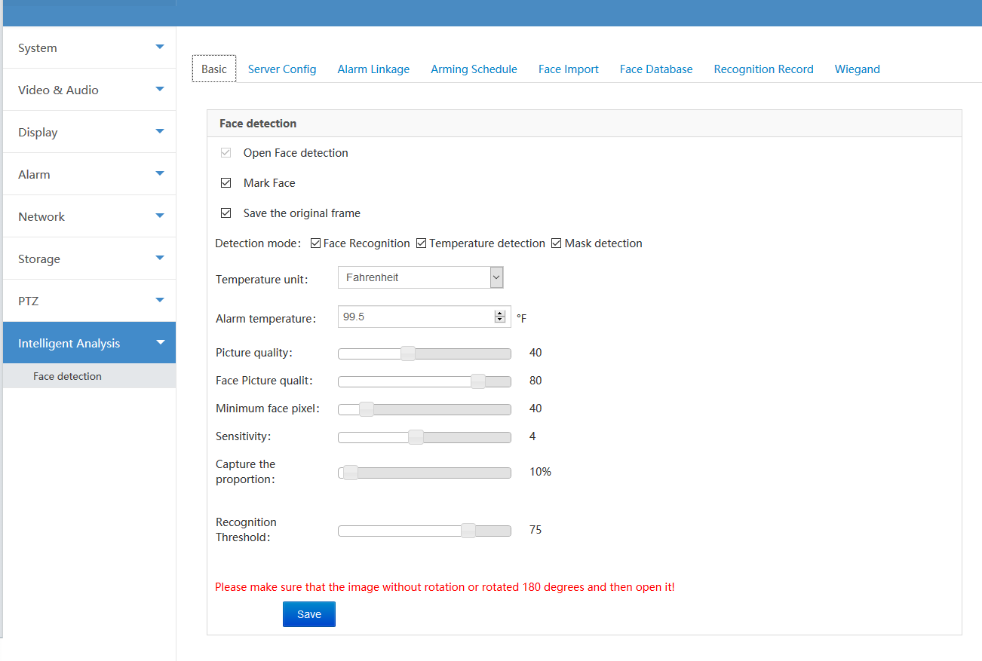

Note: The three detection mode options can be combined together to detect the required item.

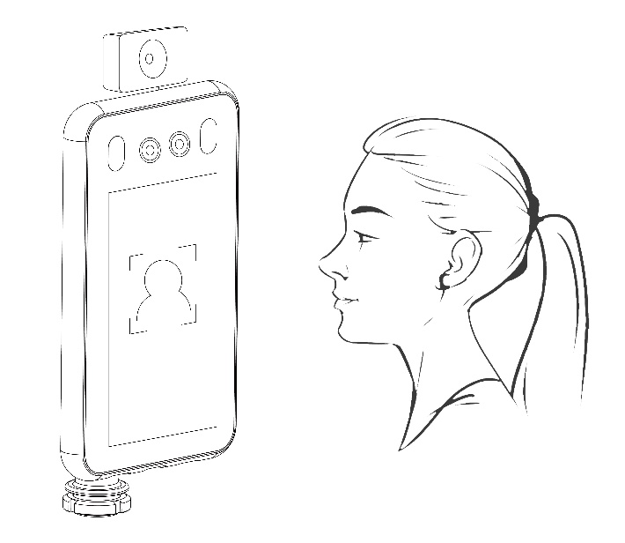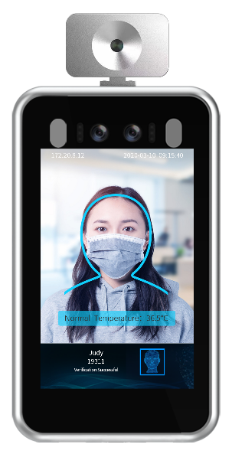Step 2: Place the face in the designated detection frame to measure the temperature. The specific temperature will be displayed during the recognition check and there will be Normal/Abnormal Temperature voice announcements.

Step 3: Got to **Intelligent Analysis -> Face Detection -> Recognition Record**. There will be information records such as Body temperature of the captured person and other details.

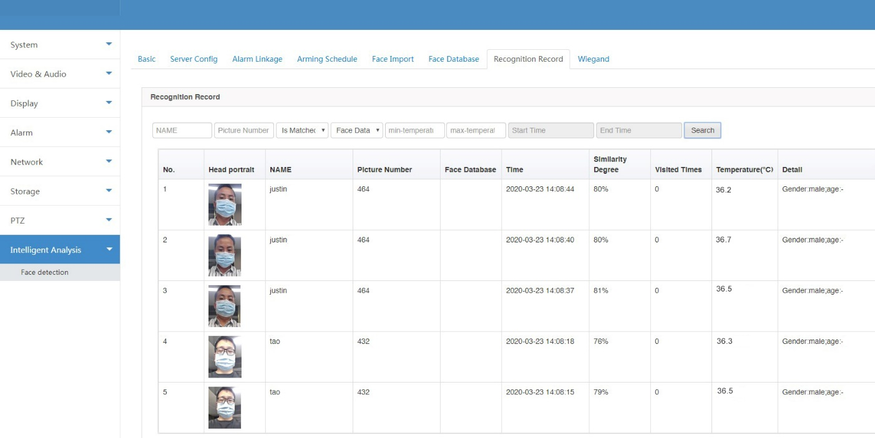

**Mask Detection**

Go to **Intelligent Analysis -> Face Detection -> Basic.** You can enable or disable the Mask Detection function. If its enabled, it gives you voice announcements when the person is detected without mask and it restrict the person to access the entry.

**Face Detection**

* + - 1. Basic Settings

Go to **Intelligent Analysis -> Face Detection -> Basic**. By default, the Face detection functions is enabled in the device. You can adjust other parameters according to the required situation. (It is recommended that the Sensitivity adjusted to 2 and the Threshold is about 75)



1. Face Import

Go to **Intelligent Analysis -> Face Detection -> Face Import**. First edit the pictures according to the specification requirements below.

1) The picture format must be .jpg format and the size cannot exceed 512KB.

2) The name format of the pictures must be: name_number_gender.jpg.

3) The maximum resolution of the pictures should be 960x960, and the minimum resolution should be 30x30.

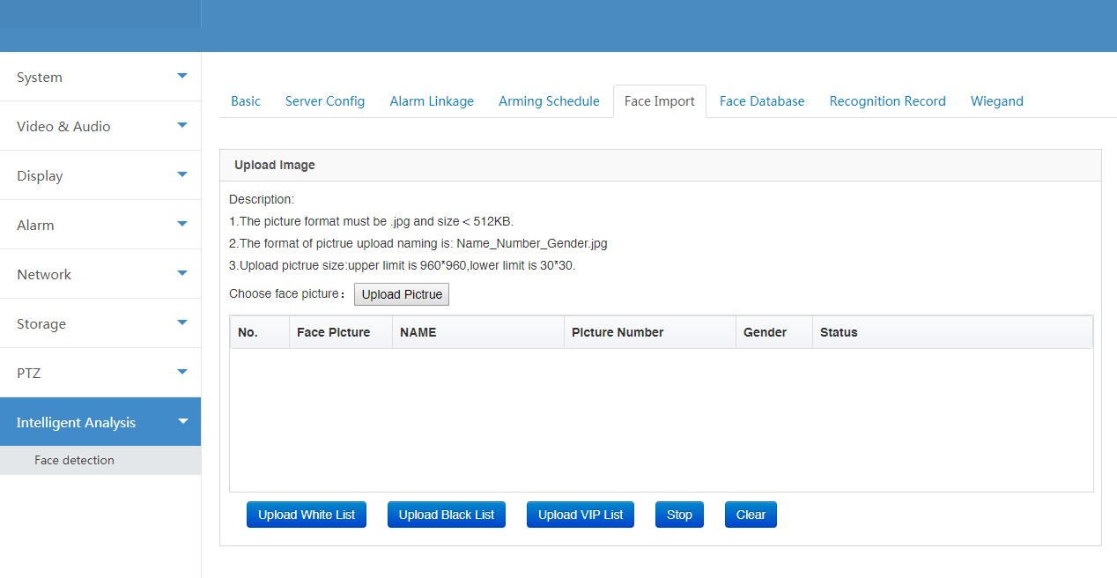

Note: You can select multiple images to import at the same time.

Click **Upload Picture** button and select the images you want to upload. Click **Upload White List**, **Upload Black List** or **Upload VIP List** buttons to upload the faces into the database.

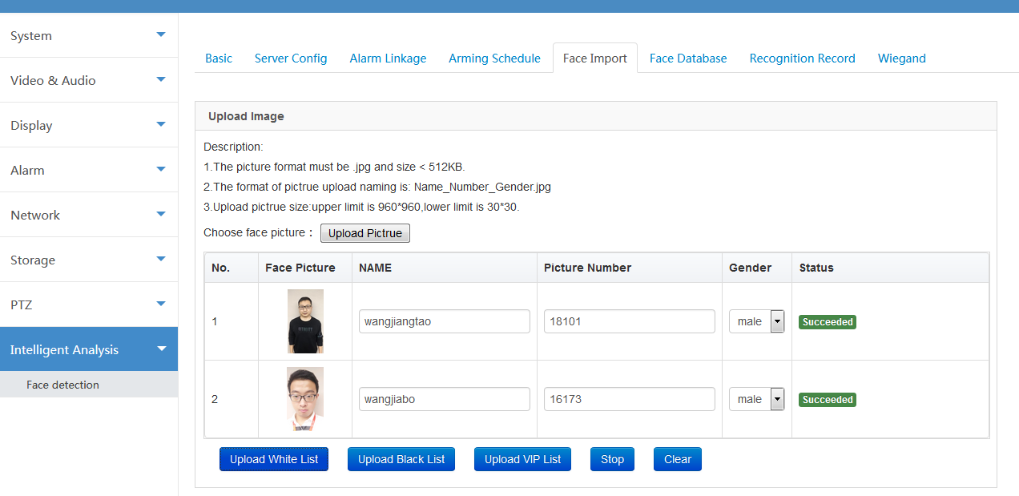

1. Face Database

Go to **Intelligent Analysis -> Face Detection -> Face Database.** Once the image uploaded successfully, you can View, Edit and Remove the pictures from the database.

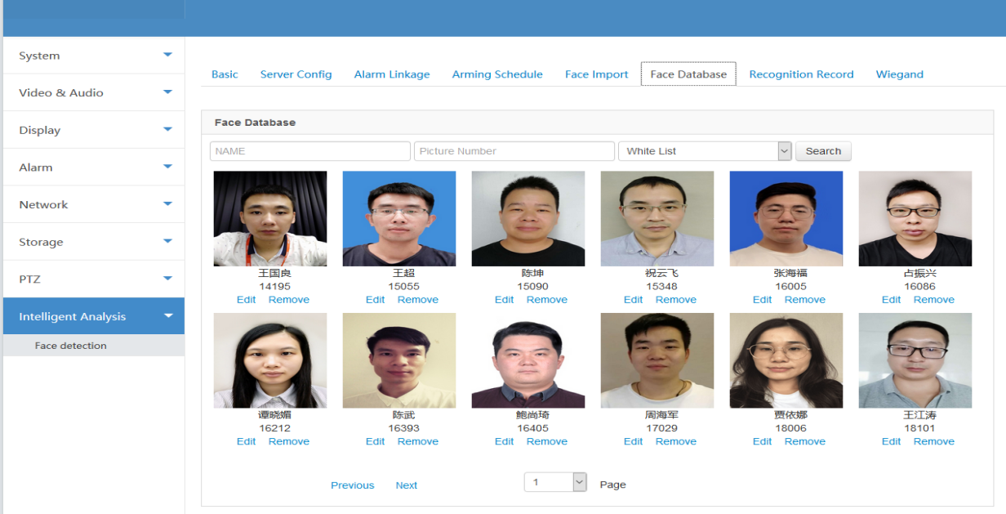

1. Recognition Record

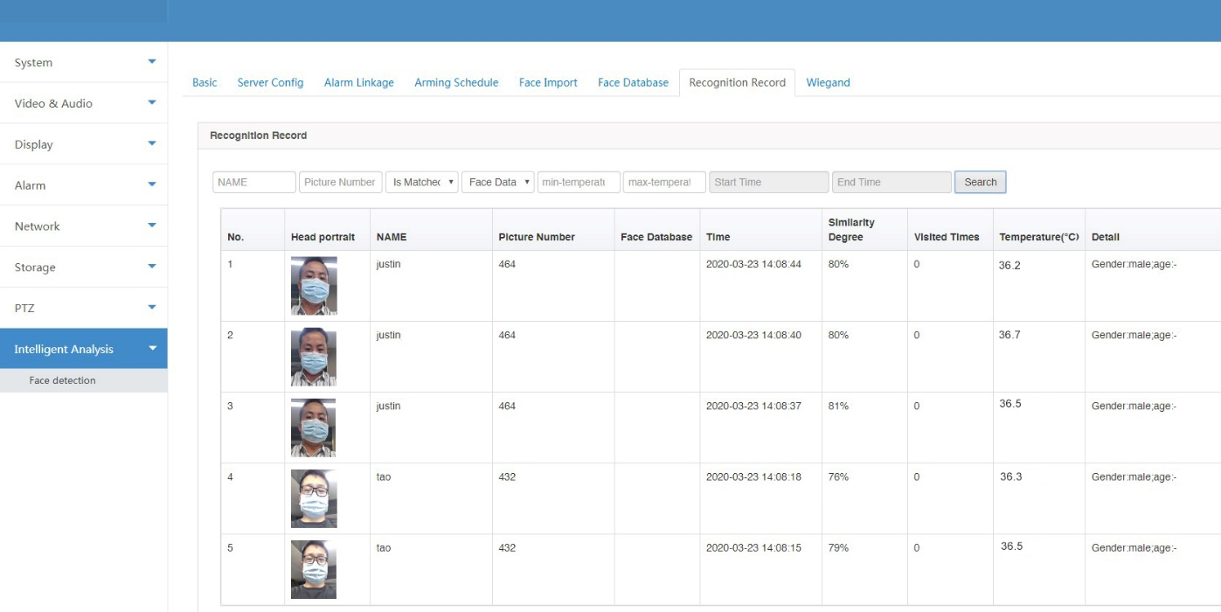Go to **Intelligent Analysis -> Face Detection -> Recognition Record.** If the verification is successful, the specific date & time and other information of the person will be displayed in the Recognition Record.

**Firmware Update**

Go to **System -> Maintenance**. Select **File Update** as the update method. Choose Version File and Update File from the directory. Click on **Update** button to update the device firmware.

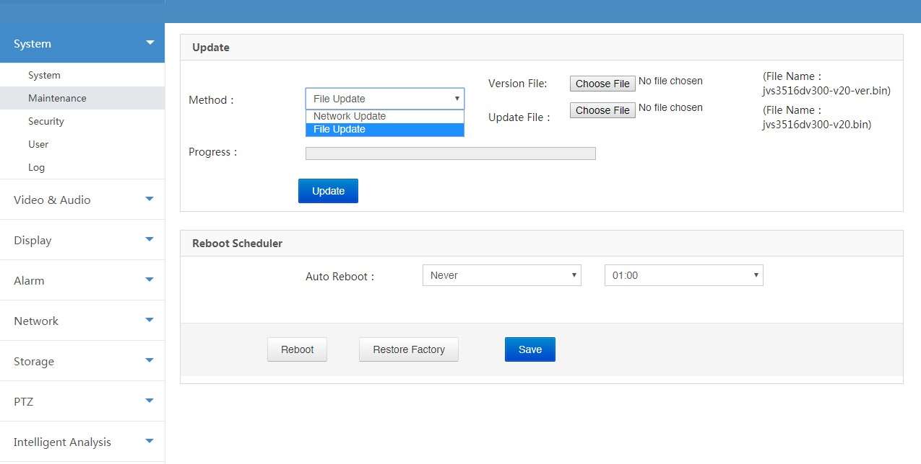Note: Do not interrupt the power or network during the firmware update process. It may damage the product.

**Technical support**

If you have any problems with the device, please contact the dealer that you purchased from. If your problem still can’t be resolved, please send your Email to the headquarter technical support team at: [**support@jovision.com**](mailto:support@jovision.com)

We welcome your valuable comments and suggestions on improving our products.