**BD-DM02**

**Blackbody**

**User Manual**

# Statement

Thank you for choosing our product. This user manual is intended for users of Blackbody. It includes instructions on how to use the product. Before using the device, read the user manual carefully. Keep this manual for further clarifications. The descriptions, images and technical parameters may vary with the actual devices. The software embodied in the product is governed by the user license agreement covering that product.

**Regulatory Information**

**FCC Caution.**

This device complies with part 15 of the FCC Rules. Operation is subject to the following two conditions: (1) This device may not cause harmful interference, and (2) this device must accept any interference received, including interference that may cause undesired operation.

Any Changes or modifications not expressly approved by the party responsible for compliance could void the user's authority to operate the equipment.

**Note**: This equipment has been tested and found to comply with the limits for a Class B digital device, pursuant to part 15 of the FCC Rules. These limits are designed to provide reasonable protection against harmful interference in a residential installation. This equipment generates uses and can radiate radio frequency energy and, if not installed and used in accordance with the instructions, may cause harmful interference to radio communications. However, there is no guarantee that interference will not occur in a particular installation. If this equipment does cause harmful interference to radio or television reception, which can be determined by turning the equipment off and on, the user is encouraged to try to correct the interference by one or more of the following measures:

-Reorient or relocate the receiving antenna.

-Increase the separation between the equipment and receiver.

-Connect the equipment into an outlet on a circuit different from that to which the receiver is connected.

Consult the dealer or an experienced technician for help.

**RF warning**:

This equipment complies with FCC radiation exposure limits set forth for an uncontrolled environment. This equipment should be installed and operated with minimum distance 20cm between the radiator & your body.

**EU Conformity Statement**

This product and if applicable, the supplied accessories too are marked with "CE" and comply therefore with the applicable harmonized European standards listed under the Low Voltage Directive 2014/35/EU, the EMC Directive 2014/30/EU, the RED directive 2014/53/EU, the RoHS Directive 2011/65/EU.

This product can be used across EU member states.

The simplified EU declaration of conformity referred to in Article 10(9) shall be provided as follows:

We hereby declare that the radio equipment type (HD Network Camera) is in compliance with Directive 2014/53/EU.

2012/ 19/ EU (WEEE directive): Products marked with this symbol cannot be disposed of as unsorted municipal waste in the European Union. For proper recycling, return this product to your local supplier upon the purchase of equivalent new equipment, or dispose of it at designated collection points. For more information see: [www.recyclethis.info](http://www.recyclethis.info)

2006/ 66/ EC (battery directive): This product contains a battery that cannot be disposed of as unsorted municipal waste in the European Union. See the product documentation for specific battery information. The battery is marked with this symbol, which may include lettering to indicate cadmium (Cd), lead (Pb), or mercury (Hg). For proper recycling, return the battery to your supplier or to a designated collection point. For more information see: [www.recyclethis.info](http://www.recyclethis.info)

**Open Source Software License**

This product contains software whose right holders license it under the terms of the GNU General Public License, version 2 (GPLv2), version 3 (GPLv3) and/or other open source software licenses. If you want to receive the complete corresponding source code, we will provide you and any third party with the source code of the software licensed under an open source software license if you send us a written request by mail or email to the following addresses:

Jovision OSS support team Email: opensource@jovision.com

Postal: Jovision Technology Co., Ltd.

Floor 12 Building No.3 , Aosheng Square, NO.1166 Xinluo Street, Jinan, Shandong, China

Detailing the name of the product and the firmware version for which you want the source code and indicating how we can contact you.

Please note that we will ask you to pay us for the costs of a data carrier and the postal charges to send the data carrier to you. The amount can be varied according to your location and Geniatech oss support team will notify the exact cost when receiving the request. This offer is valid for three years from the moment we distributed the product and valid for as long as we offer spare parts or customer support for that product model.

**Important Safety Instructions**

* Read and keep these instructions.
* Ensure that your installation area can safely support 3 times the weight of the blackbody.
* Do not install the blackbody in extreme temperature conditions, high humidity or direct sunlight. Do not allow liquids to fall on this product.
* Do not install indoor rated blackbody where they will be exposed to rain or moisture.
* Before installing or moving the device, please turn off the power to avoid accidents such as electric shock.
* When using the device, the power plug must be properly grounded.
* Before use, please check if there is enough space around the device for heat dissipation.
* Do not touch the blackbody surface. The high temperature of the surface may cause burns.
* Do not place heavy objects on this product and do not drop the device or subject it to physical shock.
* Do not use strong or abrasive cleaners or cloth. Gently wipe the blackbody surface with soft brushes.
* Do not open the device or attempt to service it yourself. Refer all service issues to your dealer.

**Product features**

* Specially used for calibrating Thermal Cameras and Infrared Thermometers of various sizes.
* Excellent temperature uniformity of the calibration.
* Advance Intelligent temperature controller used for temperature accuracy.
* Quick heating and temperature control.

**Technical Specifications**

1. Temperature Range：35°C ~ 45°C
2. Emissivity：0.97±0.02
3. Resolution：0.1°C
4. Radiation Area：78mm x 78mm.
5. Temperature Stability：±（0.1 ~ 0.2）°C
6. Temperature Uniformity：±0.2°C
7. Power：AC220V/50Hz
8. Size: 240mmX110mmX150mm
9. Weight: 2.0Kg
10. Working Condition: Temperature 0°C ~ 30°C, Humidity ≤65%

**Product Overview**

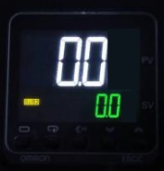

Control Panel

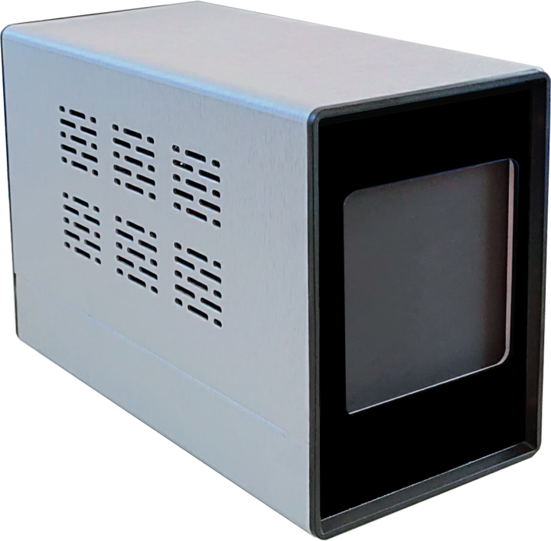

Note: The product showing in the manual is just for reference only. Appearance of the products may vary with different models

**Operation**

1. Connect the power supply to the blackbody. The power supply is single phase AC220V.
2. Press the power switch and the indicator light will on.
3. The default temperature is 35°C. The temperature will automatically heat up to 35°C when the device is powered on. If the user set another temperature value during the operation, it will automatically heat up to the temperature set last time when it is power on next time
4. 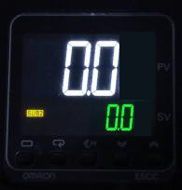Temperature Set:

On control panel, Press ◄, ▲ and ▼ buttons to adjust SV (Set Value) to set the required temperature. After adjustment, wait until the number does not change and the temperature stability for 1 minute then it can use to measure.

Note:

1. In order to ensure the accuracy of temperature measurement, please place the surface temperature calibrator in a stable temperature environment. The ideal environment temperature is 10°C ～ 25°C.
2. Do not modify parameters by yourself when it is not necessary. All parameters of the intelligent temperature controller are optimized.
3. When using it the next day, you need to warm up the device for 30-45 minutes before using it.
4. After use, turn off the device power.
5. This device is only used for the measurement of human body temperature with the help of thermal imaging devices.
6. Do not touch the surface of the blackbody with your hands or wipe it with cloth. Gently wipe the blackbody surface with soft bristle brush.
7. When not in use, please cover the blackbody surface with a cover to prevent from dust falling on the radiation surface.

**Technical support**

If you have any problems with the camera, please contact the dealer that you purchased from. If your problem still can’t be resolved, please send your Email to the headquarter technical support team at: **support@jovision.com**

We welcome your valuable comments and suggestions on improving our products.